1) EC2 INSTANCE TYPES.
1. General Purpose Instances
Balanced CPU, memory, and networking.
These are the “normal everyday servers.”
Best For
- Websites
- Small/medium apps
- Development/testing
- Backend APIs
Popular Families
- t3, t4g
- m5, m6
Example
t3.micro
m5.large
Characteristics
- Balanced performance
- Cost-effective
- Good starting choice

2. Compute Optimized Instances
High CPU power.
Designed for workloads needing strong processing.
Best For
- Gaming servers
- Video encoding
- Scientific calculations
- High-performance web servers
- Batch processing
Popular Families
- c5
- c6
Example
c5.large
Characteristics
- More vCPUs
- Faster processors
- Less RAM compared to CPU

3. Memory Optimized Instances
Large RAM (memory).
Designed for applications storing lots of data in memory.
Best For
- Databases
- Redis/Memcached
- Big data
- Real-time analytics
- SAP/HANA
Popular Families
- r5
- x1
- z1d
Example
r5.large
Characteristics
- High RAM
- Faster memory access
- Expensive compared to general purpose

4. Accelerator Optimized Instances
Uses GPUs or special accelerators.
Built for AI, graphics, and heavy parallel processing.
Best For
- Machine Learning
- AI training
- Video rendering
- 3D graphics
- Deep learning
Popular Families
- p → AI/ML GPUs
- g → graphics rendering
- inf → inference acceleration
Example
p3.2xlarge
g4dn.xlarge
Characteristics
- NVIDIA GPUs
- Very powerful
- Expensive
- Used in ML/AI workloads

5. Storage Optimized Instances
Fast and high-capacity storage.
Designed for applications reading/writing huge amounts of data.
Best For
- Large databases
- Data warehousing
- Elasticsearch
- NoSQL databases
- Big data analytics
Popular Families
- i3
- d2
- h1
Example
i3.large
Characteristics
- High disk IOPS
- NVMe SSD storage
- Fast read/write speeds
WHEN YOU TRY TO LAUNCH THE INSTANCE IN INSTANCE TYPE WHEN YOU CLICK ON COMPARE INSTANCE TYPE THAT TIME YOU CAN CHOOSE DIFF TYPE.
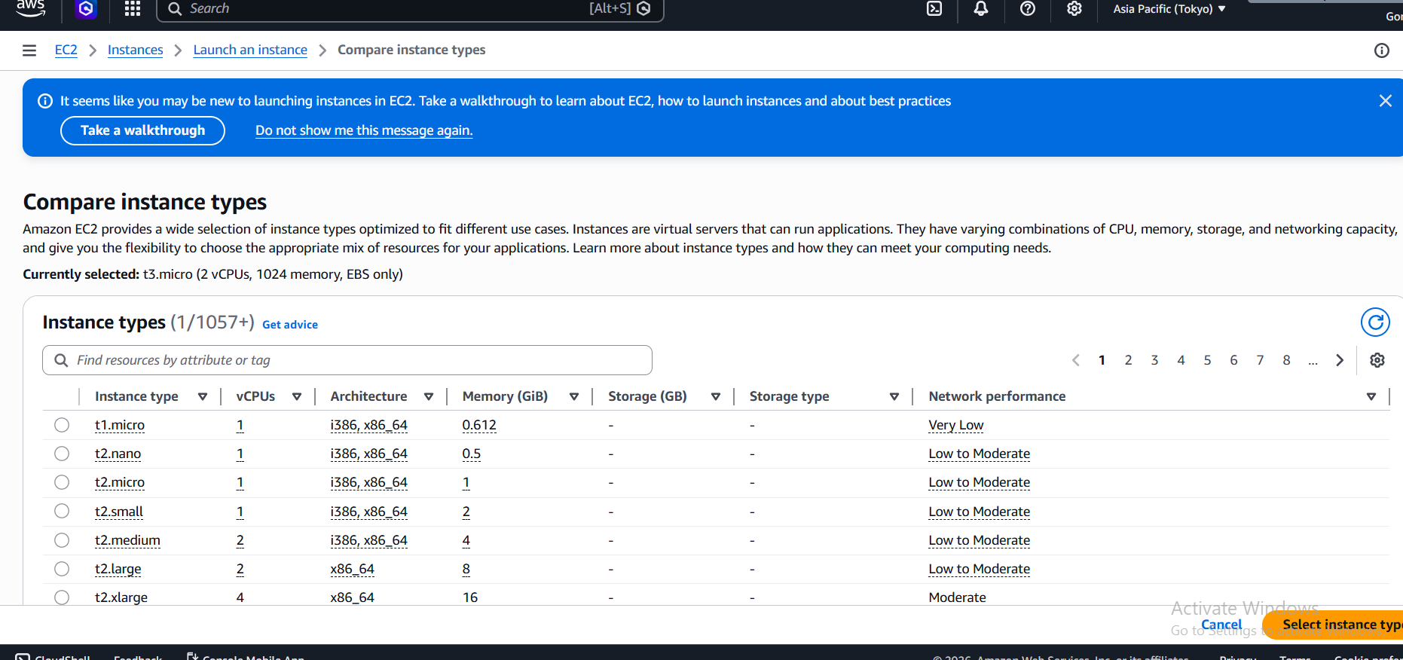

2)EC2 INSTANCE PURCHASING OPTIONS

1. On-Demand Instances
Pay only when you use the instance.
No long-term commitment.

Best For
- Testing
- Learning AWS
- Short-term apps
- Unpredictable workloads

Example
You launch:
t3.micro
for 5 hours.
AWS charges only for those 5 hours.
If you stop/delete it:
- billing stops (except storage).

Real-Life Analogy
Like booking a hotel room for one night.

2. Reserved Instances (RI)
You commit to using AWS for:
- 1 year OR
- 3 years
In return:
- AWS gives big discounts.

Best For
- Long-running production servers
- Predictable workloads

Example
Your company always runs:
m5.large
database server 24/7.
Instead of On-Demand pricing:
- reserve it for 1 year
- save up to ~70%.

Convertible Reserved Instance
Special RI that allows changing instance families later.
More flexible.

Example
Today:
m5.large
Later you need:
c5.large
Convertible RI lets you switch.

Real-Life Analogy
Like a yearly gym membership with discounts.

3. Savings Plans
Modern replacement for Reserved Instances.
You commit to spending a fixed amount per hour.
Example:
$5/hour for 1 year
AWS gives discounts automatically.

Types of Savings Plans

A. Compute Savings Plans
Most flexible.
Can change:
- instance type
- region
- OS

Example
Today:
t3.micro
Tomorrow:
m5.large
Still gets discount.

B. EC2 Instance Savings Plans
Less flexible but bigger discounts.
Locked to:
- specific instance family
- region

Real-Life Analogy
Like a monthly mobile recharge plan.

4. Spot Instances
Unused AWS capacity sold very cheaply.
Discount:
- up to 90%.
BUT:
- AWS can terminate anytime.

Best For
- Batch jobs
- Testing
- Big data
- Fault-tolerant apps
NOT good for:
- important production servers

Example
AI training job:
p3 GPU instance
Normal price:
$3/hour
Spot price:
$0.50/hour
Huge savings.

Real-Life Analogy
Like airline standby tickets.
Cheap but not guaranteed.

5. Dedicated Hosts
Physical server dedicated ONLY to you.
You control:
- sockets
- cores
- host visibility

Best For
- License compliance
- Regulatory requirements
- Enterprise software

Example
Some software licenses require:
1 physical server per customer
Dedicated Host provides that.

Real-Life Analogy
Renting an entire apartment building.

6. Dedicated Instances
Instances run on hardware dedicated to one customer.
But:
- you don’t control the physical host.

Best For
- Isolation/security requirements

Difference from Dedicated Host
Feature | Dedicated Host | Dedicated Instance
Physical server visibility | Yes | No
Control over host | Yes | No
License flexibility | High | Medium

Real-Life Analogy
Dedicated room inside a private building.

7. Capacity Reservations
Reserve capacity in a specific Availability Zone.
Ensures:
AWS always has space for your instance

Best For
- Critical applications
- Disaster recovery
- Important launches/events

Example
Before Black Friday:
- company reserves 100 EC2 instances
- guarantees availability during traffic spike.

Purchase Reserved Instance (1 Year)

Step 1: Open EC2 Console
AWS EC2 Console

Step 2: In Left Menu
Go to:
Reserved Instances
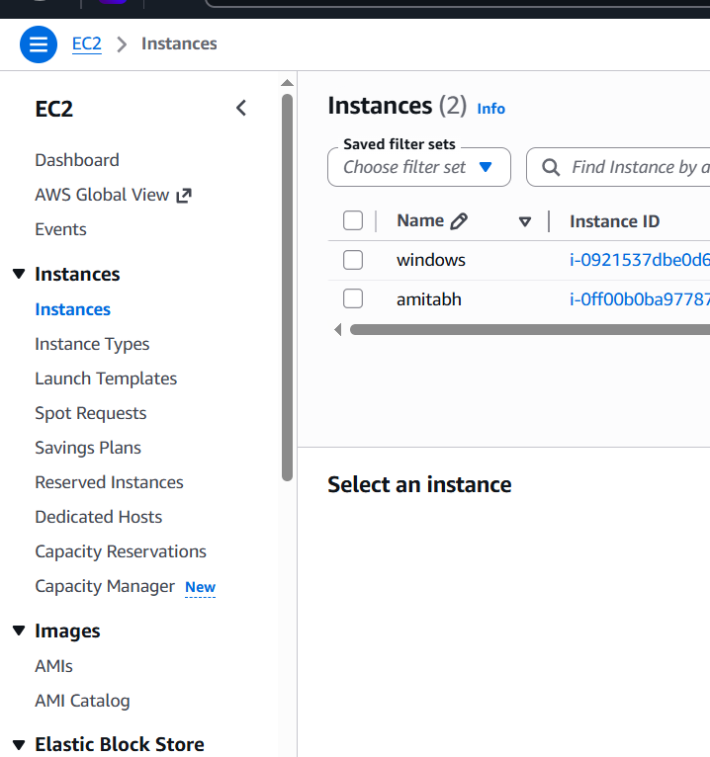

Step 3: Click
Purchase Reserved Instances
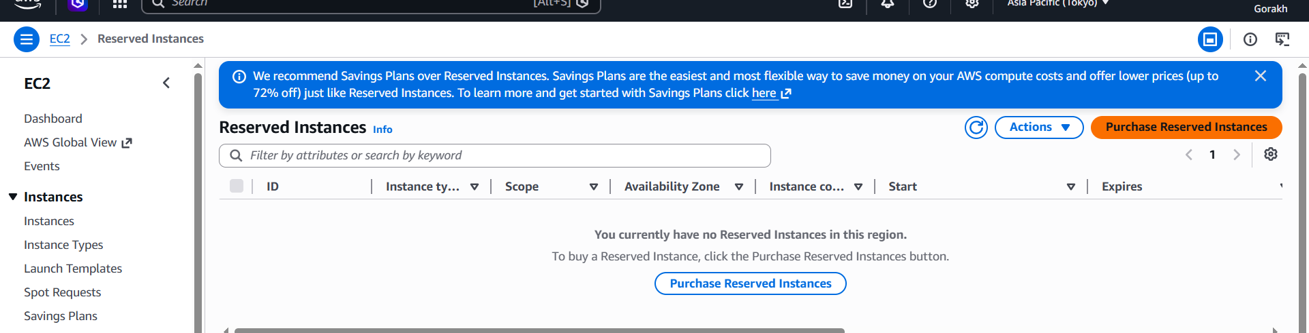

Step 4: Choose Configuration
Example:
Setting | Example
Region | Mumbai
Instance Type | t3.micro
Platform | Linux
Term | 1 Year
Payment | No upfront / Partial / All upfront

Step 5: Review and Purchase
Click:
Add to Cart → Purchase

3)EC2 Things That Are Billable

1. Running EC2 Instances
Main billing item.
You pay for:
- Running time
- Instance type size
- Operating system

Example
t3.micro = cheaper
m5.large = more expensive
Linux instances are usually cheaper than Windows.

2. EBS Volumes (Storage)
Your virtual hard disk.
Even if the instance is stopped, EBS storage still costs money.

Billable For
- SSD/HDD size (GB)
- Provisioned IOPS
- Snapshots

Example
30 GB EBS volume

3. Elastic IP (Public Static IP)
Usually:
- Free when attached to a running instance
- Charged when unused
If you allocate IPs and don’t use them, AWS charges you.

4. Data Transfer

Usually Charged
- Internet outbound traffic

Usually Free
- Inbound traffic
Example:
- Uploading to EC2 → mostly free
- Downloading from EC2 → charged

5. Load Balancers
If using:
- Application Load Balancer
- Network Load Balancer
You pay hourly + traffic usage.

6. Snapshots
Backups of EBS volumes.
Stored in S3 internally and charged per GB.

7. NAT Gateway
Common hidden cost for beginners.
NAT Gateway charges:
- Per hour
- Per GB processed
Can become expensive quickly.

8. Windows Licensing
Windows EC2 instances cost more because:
- Windows license fee included

9. Elastic GPUs / Accelerators
GPU instances are expensive.
Examples:
p3
g4dn
Used for AI/ML.

10. Auto Scaling Extra Instances
If Auto Scaling launches more servers:
- Each extra instance is billed.

Things Usually NOT Billable / Free 🆓

1. stopped EC2 Instance
When stopped:
- CPU/RAM billing stops
BUT:
- EBS storage still billed.

2. Security Groups
Free.
Acts like firewall rules.

4. VPC Basic Networking
Basic VPC usage is free.

5. IAM Roles
Free.
User/permission management.

6. Auto Scaling Configuration
The configuration itself is free.
Only launched resources cost money.

4) TYPES OF IPS:
In Amazon Web Services EC2, every instance can have different kinds of IP addresses.
The 3 important ones are:
- Private IP
- Public IP
- Elastic IP

1. Private IP
Used for communication inside AWS network only.
Cannot be accessed directly from the internet.

Example
172.31.25.10
This IP works:
- between EC2 instances
- with databases
- inside the VPC

Characteristics
✅ Internal communication
✅ Automatically assigned
✅ Free
✅ Stays with instance while running/stopped
❌ Not accessible from internet

Real Example
Your architecture:
Web Server → Database Server
Web server connects to DB using private IP.

2. Public IP
Used for internet communication.
Allows:
- SSH
- websites
- APIs
- remote access

Example
3.110.25.8
You can open in browser:
http://3.110.25.8

Characteristics
Internet accessible
Auto-assigned by AWS
Changes when instance stops/starts
Not permanent

Example Scenario
You create:
EC2 Ubuntu server
AWS gives:
- Private IP
- Public IP
You SSH using:
ssh -i key.pem ubuntu@PUBLIC-IP

3. Elastic IP (EIP)
Static public IP address.
Permanent public IP owned by your AWS account.

Example
54.210.11.20
Even if instance stops/restarts:
- Elastic IP remains same.

5)How to Allocate (Get) an Elastic IP

Step 1: Open EC2 Console
AWS EC2 Console

Step 2: In Left Menu
Go to:
Network & Security → Elastic IPs

Step 3: Click
Allocate Elastic IP address

Step 4: Keep Default Settings
Usually:
Amazon pool of IPv4 addresses
Then click:
Allocate
AWS gives you a static public IP.

6)AWS CALCULATOR

How to Use AWS Calculator for EC2

Step 1: Open Calculator
AWS Pricing Calculator

CLICK ON THIS TAB.
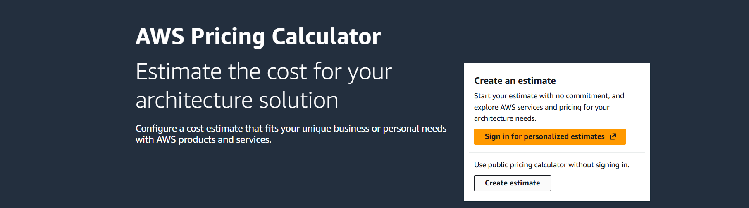
CLICK ON CREATE ESTIMATE

Step 2: Search for EC2
In the search bar type:
EC2
Click:
Amazon EC2

Step 3: Configure Your EC2 Instance
You will enter details like:

Region
Example:
US East (N. Virginia)
Mumbai
Singapore
Different regions have different pricing.
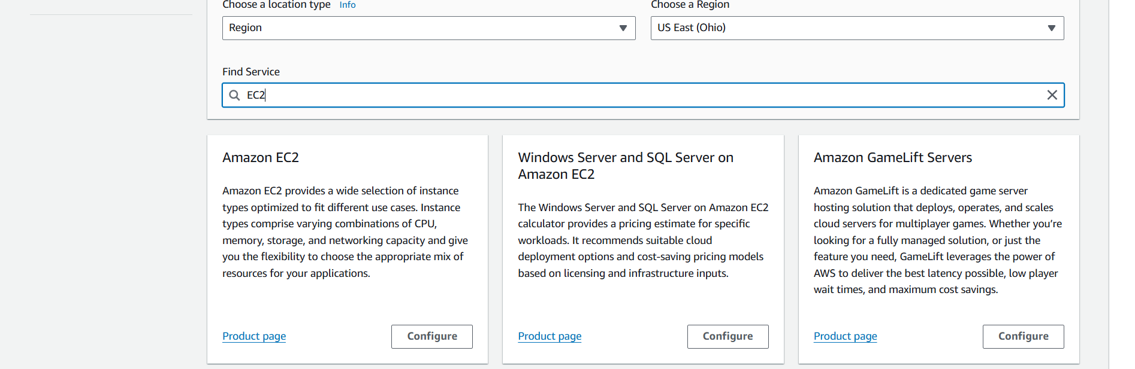
CLICK ON CONFIGURE

Operating System
Example:
Linux
Windows
Ubuntu
Red Hat
Windows costs more.
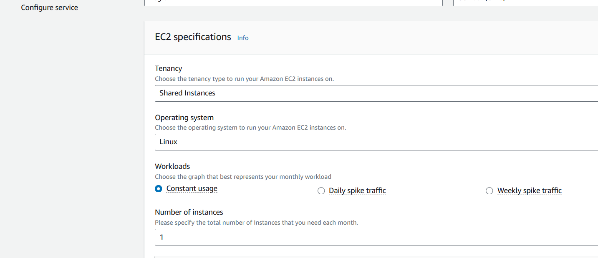

Instance Type
Example:
t3.micro
m5.large
c5.large
This determines:
- CPU
- RAM
- price

Number of Instances
Example:
1
5
10
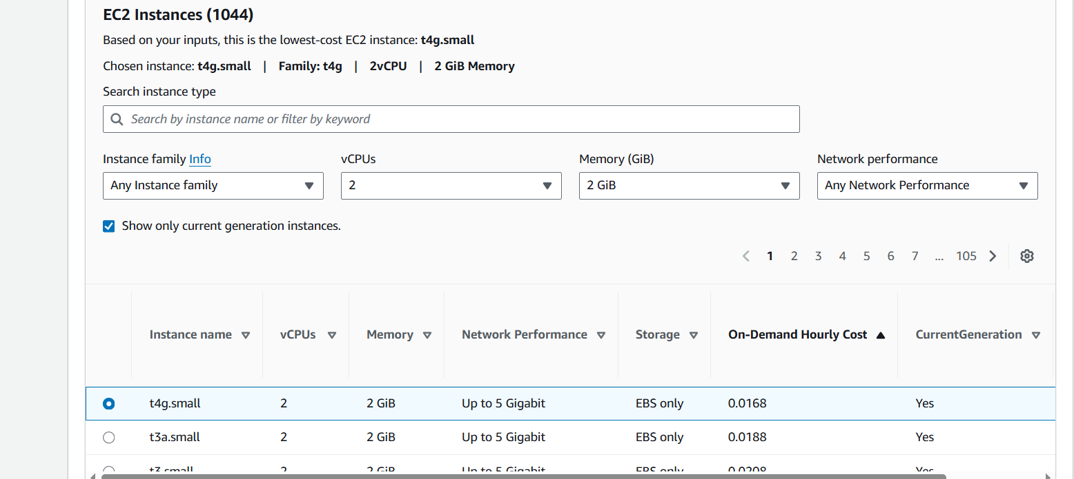

Usage Time
Example:
730 hours/month
(24×7 full month)

Storage (EBS)
Example:
30 GB SSD
Storage cost added separately.
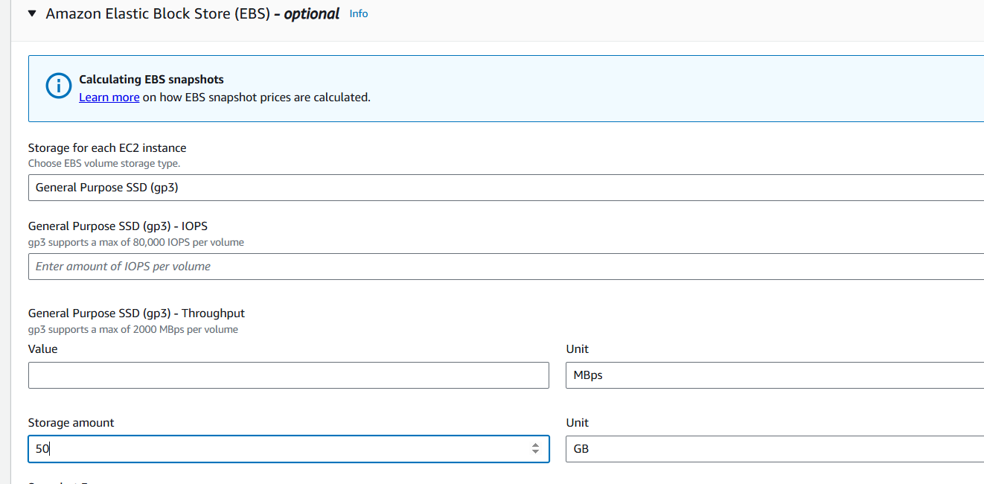

Data Transfer
Estimate internet traffic.
Example:
100 GB outbound
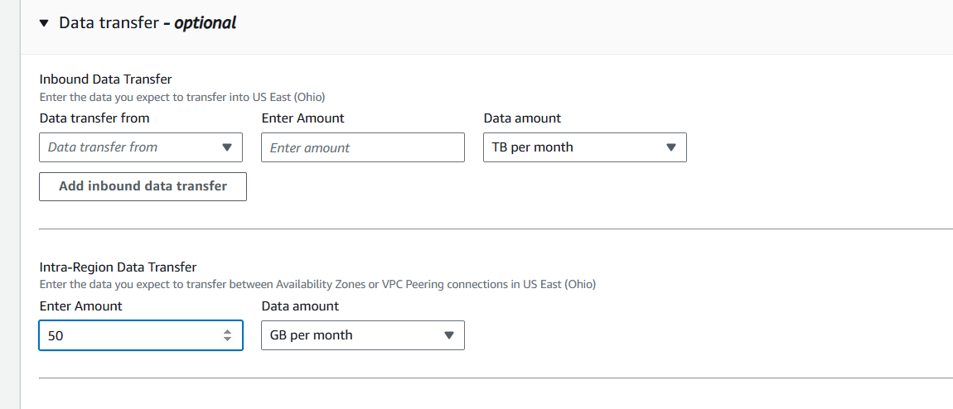
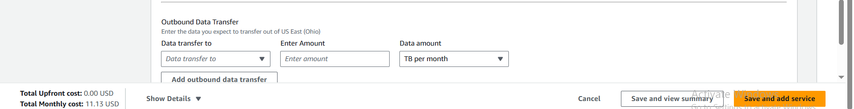
CLICK ON SAVE AND VIEW SUMMARY.
